Design Doc Template

*Author(s): B.shirisha reddy*

*C. Anusha Yadav*

*N. Mohana Yadav*

*Date: 22/05/2019*

Revision: 0

Document Status: Draft [Draft, Completed, Submitted, Reviewed, Final]

Project Status: In-Progress [In Review, Approved, In-Progress, Completed]

Revision History

|  |  |  |  |
| --- | --- | --- | --- |
| Date | Revision | Description | Author |
| 22/05/2019 | 0 |  |  |
|  |  |  |  |
|  |  |  |  |
|  |  |  |  |
|  |  |  |  |
|  |  |  |  |
|  |  |  |  |
|  |  |  |  |
|  |  |  |  |
|  |  |  |  |

Table of Contents

TOC \o "1-3" \h \z \u Introduction4

Summary4

Background4

Definitions, Acronyms, and Abbreviations4

Design Overview4

Requirements4

Documentation4

Minimum Viable Product5

Stretch goals5

Future work5

Architectural Diagrams5

System Diagrams5

Application Programming Interface5

Recommendations5

User Interface6

Data Models and Storage6

Service Operability6

Key Performance Indicators6

Service Level Objectives6

Project Overview7

Communication and Tracking7

Risks7

Milestones7

Project Phases7

Cost7

Frequently Asked Question7

References7

Addendum8

# Introduction

## Summary

* A predictive maintenance algorithm which alerts the operations personnel on the condition of duct fan is proposed. The algorithm differentiates between obstruction to air flow and dust. Deposit on the impeller blades. Besides this, the status (running/stalled) of the duct fan is continuously logged to cloud for remote monitoring.

## Background

We visited thermal power plant at RAMAGUNDAM. There we find the problem with duct fans maintenance (schedule maintenance) which decreases the efficiency. This problem can be overcome by predictive maintenance. Good efficiency requires very small clearances between the blade tips and the duct.

## Definitions, Acronyms, and Abbreviation

# Design Overview

## Requirements

* Accelerometer
* Arduino Due
* Arduino uno
* Thingspeak cloud
* Battery
* Ductfan

### Documentation

## Future work

To maximize the accuracy level of the output.

# System Diagrams

# 

# Application Programming Interface

Industrial

commercial

# 

# User Interface

Maintenance of duct fans is predicted.

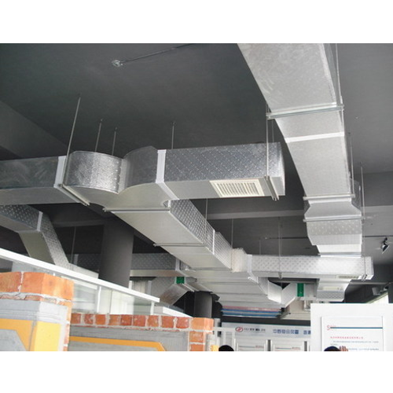

# Project Overview

## Communication and Tracking

* Business network
* Advertisement in local channels
* Social media
* Creating web pages

## Risks

If product is damaged then human health (employees and people) may be effected. Replacing of the product may be costly affair. Due to temperature accuracy of the product may be affected.

## Cost

3000

# Frequently Asked Question

Why accelerometer is used in our project?

What is the need of two microcontrollers?

References

[https://www.hackstar.io/matlab-iot/condition-based- maintenance-of-a-duct-fan-using-thingspeak-abb23d](https://www.hackstar.io/matlab-iot/condition-based-%20maintenance-of-a-duct-fan-using-thingspeak-abb23d)

[www.amca.org/whitepapers](http://www.amca.org/whitepapers)

Application Notes: vibration diagnostics for industrial electric motor drives, Bruel and kjaer